A
Mini Project Report
on
Shop Smart AI
Submitted in partial fulfillment of the requirements for the
degree
Third Year Engineering – Computer Science Engineering (Data Science)
by
Sarvesh Deve | 23107020
Harshal Gaikwad | 23107053
Atharva Barve | 23107072
Shubham Khade | 23107013

Under the guidance of

Prof. Aavani N

DEPARTMENT OF COMPUTER SCIENCE ENGINEERING (DATA SCIENCE)
A.P. SHAH INSTITUTE OF TECHNOLOGY
G.B. Road, Kasarvadavali, Thane (W)-400615
UNIVERSITY OF MUMBAI

Academic year: 2025-26

CERTIFICATE

This to certify that the Mini Project report on ‘Shop Smart AI’ has been submitted by Sarvesh Deve (23107021), Harshal Gaikwad (23107053), Atharva Barve (23107072) and Shubham Khade (23107013) who are bonafide students of A. P. Shah Institute of Technology, Thane as a partial fulfillment of the requirement for the degree in Computer Science Engineering (Data Science), during the academic year 2025-2026 in the satisfactory manner as per the curriculum laid down by University of Mumbai.

Ms. Aavani N
Guide

Dr. Pravin Adivarekar Dr. Uttam D. Kolekar
HOD, CSE(Data Science) Principal

External Examiner: Internal Examiner:
- 1.

Place: A. P. Shah Institute of Technology, Thane
Date:

ACKNOWLEDGEMENT

This project would not have come to fruition without the invaluable help of our guide Ms. Aavani N. Expressing gratitude towards our HoD, Dr. Pravin Adivarekar, and the Department of Computer Science Engineering (Data Science) for providing us with the opportunity as well as the support required to pursue this project. We would also like to thank our project coordinator Prof. Sarla Mary and Prof Aishwaray Londe who gave us her valuable suggestions and ideas when we were in need of them. We would also like to thank our peers for their helpful suggestions.

TABLE OF CONTENTS
Abstract
- Introduction………………………………………………………………………..1
  - Purpose.............................................................................................................1
  - Problem Statement…………………………………………………………...2
  - Objectives........................................................................................................ 2
  - Scope.........................................................................................................…...3
- Literature Review……………………………………………………………….....4
- Proposed System………...........................................................................................7
  - Features and Functionality…………………………………………………...7
- Requirements Analysis............................................................................................. 9
- Project Design..........................................................................................................10
  - Use Case diagram……………………………………………………… …...10
  - DFD (Data Flow Diagram) ………………………………………………….11
  - System Architecture………………………………………………………….12
  - Implementation……………………………………………………………….13
- Technical Specification……………...…………………………………………......14
- Project Scheduling....................................................................................................15
- Results……………..……………………………………………………………….16
- Conclusion…………………....................................................................................17
- Future Scope……………………………………………………………………….18
References

ABSTRACT

The ShopSmart AI project aims to address the fragmented nature of existing e-commerce and grocery recommendation systems by providing a comprehensive, all-in-one solution for informed purchasing decisions. Current systems, which include technologies like., Apriori/Association Rule Mining, Collaborative Filtering, Content-based Filtering, and Rule-Based Filtering, offer limited personalization, lack integration with budget data, and ignore important factors like sustainability and nutritional needs. Our proposed system integrates these functionalities by providing a platform that not only offers personalized recommendations but also incorporates budget, nutritional, and sustainability constraints. By combining multiple methodologies, ShopSmart AI enhances the user experience by helping them find products that are not only desirable but also aligned with their financial, dietary, and environmental goals. The project focuses on original design and customization to provide a valuable, holistic solution that goes beyond basic recommendations.

Chapter 1
Introduction
ShopSmart AI is a comprehensive platform designed to revolutionize the grocery shopping experience by providing users with intelligent, data-driven recommendations. It aims to make shopping more efficient, cost-effective, and aligned with personal preferences and goals. The platform offers a seamless and intuitive solution that goes beyond traditional recommendation systems, providing a holistic view of products by considering multiple factors simultaneously.

Users can navigate an extensive database of products, which are enriched with information on price, nutritional value, and sustainability ratings. ShopSmart AI empowers consumers to make well-informed choices by integrating these diverse data points into a cohesive and user-friendly interface. Unlike fragmented solutions, our system allows users to find products that fit their budget, dietary needs, and environmental values all in one place.

Beyond its core search and recommendation features, ShopSmart AI excels in providing a multi-faceted approach to smart shopping. The platform integrates personalized shopping lists, budget management tools, and performance analytics to track savings and other goals. It leverages various methodologies, including collaborative and content-based filtering, to offer highly personalized product suggestions. By centralizing all these features, ShopSmart AI transforms the often-complex process of grocery shopping into an engaging and efficient experience, empowering consumers to shop smarter and achieve their financial, health, and sustainability objectives with confidence.

1.1. Purpose
The primary purpose of ShopSmart AI is to streamline and automate the entire process of grocery shopping by providing a single, integrated platform for intelligent product recommendations. By consolidating essential information—including pricing, nutrition, and sustainability data—the system offers a seamless and efficient shopping experience. This centralized approach simplifies the preparation process, reduces the need for multiple applications, and enhances consumer decision-making.

Additionally, the system utilizes data-driven insights to provide personalized recommendations. It learns from user behavior, preferences, and constraints (such as budget and dietary restrictions) to suggest products that are not only desirable but also practical and aligned with their specific needs. By optimizing the shopping process through intelligent tools and interactive features, ShopSmart AI empowers users to save money, improve their health, and make environmentally conscious choices with confidence.

1.2. Problem Statement
The current landscape of e-commerce and grocery shopping is vast and complex, often overwhelming consumers with a lack of integrated information. Shoppers struggle to make effective decisions due to the fragmentation of tools and resources needed to compare products based on price, nutrition, and environmental impact. As noted in the literature survey, existing systems suffer from several limitations:

- Limited Personalization: Many systems, such as those using Apriori/Association Rule Mining, offer generic recommendations and lack deep personalization. These methods rely heavily on the purchasing patterns of the general population to suggest product bundles. Consequently, they fail to cater to an individual user's unique dietary needs, specific tastes, or evolving preferences over time.

- Cold Start Problem: Collaborative filtering, while highly personalized, requires large datasets and struggles to provide recommendations for new users or new items. When a user first joins the platform or a new product is added, there is insufficient data on historical interactions, leaving the system unable to generate reliable or relevant suggestions. This initial lack of data severely limits the system's effectiveness and the user's early experience.

- Lack of Integration: Nutrition and sustainability databases are often disconnected from price data and general shopping platforms, forcing users to manually cross-reference information. This fragmentation means consumers must utilize separate applications to compare cost, health information, and environmental impact, making a truly informed purchasing decision overwhelming and inefficient.

- Narrow Scope: Content-based filtering is limited by item attributes and ignores user diversity, while rule-based filtering is rigid and less adaptive to changing preferences. Content-based systems often result in a lack of variety, only suggesting items similar to past purchases. Rule-based systems, conversely, are static, struggling to incorporate spontaneous user interest or react to dynamic changes in product availability.

1.3. Objectives
The objectives of the ShopSmart AI project are to provide a seamless platform for users to find, compare, and manage their grocery shopping. The system aims to:

- Simplifying the shopping process is achieved by creating a single, comprehensive database that integrates real-time price data, detailed nutritional values, and standardized sustainability ratings for all products. This eliminates the need for users to consult multiple sources, allowing them to instantly execute complex filters based on all three factors (cost, health, and ethics) simultaneously.

- Enhancing decision-making involves providing users with both interactive control and transparent feedback. This is achieved by designing a user-friendly interface that offers interactive tools which allow users to dynamically adjust variables, such as modifying their budget or dietary constraints, and instantly see how these changes impact the optimized shopping list and overall value. Additionally, the interface provides Performance Analytics, a feature that offers a dashboard with visualizations and metrics to track, analyze, and understand the consequences of their purchasing habits, including their cumulative savings, nutritional intake, and environmental impact over time.

- Improving shopping efficiency centers on delivering highly relevant and practical recommendations by leveraging a hybrid machine learning engine. This engine uses collaborative filtering (KNN) to learn from user behavior and preferences and integrates it with Rule-Based Filtering to strictly enforce user-defined constraints (like allergies or diet). By combining these methods, ShopSmart AI overcomes the rigidness and limited personalization of existing systems, ensuring every recommendation is both desired and viable for the user.

- Promoting sustainability and healthy eating is achieved by actively encouraging users toward responsible choices through clear data and practical alternatives. The system will clearly display sustainability classifications for products and offer optimized, eco-friendly substitute suggestions when a less-sustainable item is added to the list, making ethical shopping effortless. Furthermore, by providing clear nutritional data and flagging products that exceed personalized health targets (e.g., high sugar), the platform empowers users to make conscious choices aligned with their dietary goals.

1.4. Scope
The ShopSmart AI platform is designed to serve a broad range of users, including everyday consumers, budget-conscious shoppers, health-conscious individuals, and environmentally aware buyers. It provides a comprehensive and interactive approach to grocery shopping by offering personalized recommendations, budget tracking, and product analytics to enhance efficiency and decision-making.

- Everyday Consumers & Budget-Conscious Shoppers: These users can benefit from a platform that simplifies the shopping process by providing easy access to price comparisons and budget management tools. The system helps them find the best deals and track their spending, making grocery shopping more economical.

- Health-Conscious Individuals: Users focused on their diet can leverage the platform's detailed nutritional data and rule-based filtering to find products that align with their dietary restrictions or health goals.

- Environmentally Aware Buyers: For those concerned with sustainability, the system provides classifications and eco-friendly recommendations to encourage responsible consumption.

- Developers & Data Scientists: The project's architecture and methodologies can be used as a foundation for future research and development in the field of smart consumer technology.
Chapter 2
Literature Review
This section provides a review of existing systems and methodologies relevant to e-commerce and grocery shopping recommendation platforms. The analysis identifies the strengths and limitations of current approaches, highlighting the need for a more comprehensive and integrated solution. The findings are based on a survey of various technologies and their applications in the market, including those used by major companies like Amazon, Netflix, and Spotify.
- Association Rule Mining
Association Rule Mining, particularly the Apriori algorithm, is a widely used technique for discovering frequent itemsets in transactional databases. The goal is to find all association rules that satisfy user-specified minimum support and minimum confidence constraints. It identifies products that are frequently purchased together, which is highly effective for market basket analysis and product bundling. As stated by Agrawal, Imieliński, and Swami, "The problem is to find all association rules that satisfy user-specified minimum support and minimum confidence constraints."[1] E-commerce giants like Amazon use this method to provide basic recommendations and improve sales by suggesting related products at checkout. However, the primary limitation of this approach is its limited personalization, as it relies on general purchasing patterns rather than individual user preferences, making its recommendations less tailored to specific needs or tastes.
- Collaborative Filtering
Collaborative filtering (CF) is a powerful recommendation technique that predicts user preferences by leveraging the preferences of other similar users. Two common types are user-based and item-based CF, often implemented using algorithms like K-Nearest Neighbors (KNN) or Matrix Factorization. Item-based collaborative filtering, as discussed by Sarwar et al., focuses on computing similarities between items using "a collaborative data set of users' ratings on those items".[2] Platforms such as Netflix and Spotify have successfully employed CF to provide highly personalized content suggestions. The main advantage of this method is its ability to learn from user similarities, resulting in deeply personalized recommendations. Despite its effectiveness, CF suffers from two significant drawbacks: the cold start problem, where it cannot make recommendations for new users or items due to a lack of data, and the need for large, complex datasets to produce accurate results.
- Content-Based Filtering
Content-based filtering (CBF) recommends items to a user based on the attributes of items they have previously liked. This method is commonly used in applications where item features are well-defined, such as health and fitness apps like HealthifyMe. For instance, a user who frequently logs low-sugar foods would receive recommendations for similar items. Lops, De Gemmis, and Semeraro state that the core approach of CBF is to "analyze the properties of items that the user has rated positively, and build a profile of user interests based on these properties."[3] The advantage of this approach is that it doesn't depend on other users' data. However, its scope is narrow, and it ignores user diversity by focusing solely on item attributes, which can lead to a lack of variety in recommendations.
- Rule-Based Filtering
Rule-Based Filtering utilizes a set of predefined rules to make recommendations. This method is particularly useful in applications with strict constraints, such as diet apps and calorie trackers, where it can ensure that recommended items adhere to specific dietary requirements (e.g., vegan, low-calorie, or gluten-free). Chen et al. demonstrated the utility of handling strict dietary constraints by proposing a model that can answer complex queries like "recommend me a dish that is high in protein and low in calories" over a food knowledge graph.[4] The primary benefit of Rule-Based Filtering is its ability to ensure specific health constraints are met. However, this approach is rigid and less adaptive to changes in user preferences or product availability, as the rules are manually defined and not learned from data.
- Nutrition Databases and Sustainability Classifications
Specialized databases, such as those maintained by MyFitnessPal and the USDA, provide accurate nutritional values for a wide range of food items. Vanepoel et al. conducted a validation study on a consumer-focused online app, finding that while tools like MyFitnessPal are widely used, the "accuracy of nutrient calculations still needs to be improved".[13] Additionally, some experimental applications focus on providing sustainability classifications to encourage eco-friendly choices. While these resources offer valuable, accurate data, they are not typically integrated with e-commerce platforms. This fragmentation means consumers must manually consult these separate sources, and more importantly, they are not connected with budget or price data, making it difficult for users to find products that meet all their criteria simultaneously.
- Summary of Limitations
The literature review reveals a significant limitation across all existing systems: the lack of a unified, holistic solution that addresses all facets of a user's shopping needs. Each technology excels in a specific domain—be it personalization, bundling, or meeting health constraints—but fails to integrate other critical factors. This fragmentation creates a user experience where consumers must navigate multiple platforms and manually synthesize information on price, nutrition, and sustainability, leading to an inefficient and overwhelming process. The proposed ShopSmart AI project aims to overcome these limitations by providing a single, comprehensive platform that intelligently combines these various data points to deliver truly smart recommendations.
Chapter 3
Proposed System

The proposed system, ShopSmart AI, is an innovative platform designed to address the key challenges of modern consumer shopping. It offers a comprehensive and unified solution that integrates multiple critical factors—price, nutrition, and sustainability—into a single, intelligent platform. By moving beyond the limitations of existing, fragmented systems, ShopSmart AI aims to provide a more efficient, cost-effective, and conscious shopping experience.

The core of the system lies in its ability to deliver personalized, data-driven recommendations that are tailored to the user’s specific needs and constraints. With features like real-time price comparisons, nutritional analysis, and eco-friendly product highlighting, ShopSmart AI seeks to become the definitive tool for all grocery shopping needs. It empowers users to make informed decisions effortlessly, enabling them to save money, improve their health, and support a sustainable lifestyle with confidence.

3.1. Features and Functionality
ShopSmart AI is a comprehensive consumer intelligence platform engineered to streamline and enhance the entire grocery shopping process. It offers a wide range of features and functionalities designed to cater to the diverse needs of modern shoppers.
  - User Interface and Dashboard:-
ShopSmart AI provides an intuitive dashboard with a user-friendly interface. This enables easy navigation and quick access to key functionalities, including product search, personalized recommendations, budget tracking, and shopping list management.

  - Intelligent Product Recommendation Engine:-
The system features an intelligent recommendation engine that goes beyond basic suggestions. It combines multiple methodologies to provide personalized recommendations tailored to a user's unique needs. This engine integrates:
- Collaborative Filtering: To learn from user similarities and provide personalized suggestions.
- Content-Based Filtering: To recommend items based on attributes like nutrition and category.
- Rule-Based Filtering: To ensure specific health constraints (e.g., low sugar, vegan) are met.
- Data Integration and Analytics:
ShopSmart AI consolidates and analyzes data from various sources to offer a holistic product view. This includes:
- Price Data: For real-time price comparisons and budget management.
- Nutrition Databases: To provide accurate nutritional information for products.
- Sustainability Classifications: To highlight eco-friendly choices and encourage sustainable development goals.
- Performance Analytics: To track user savings and dietary goals over time.

Chapter 4
Requirements Analysis

The requirements analysis for ShopSmart AI is a critical step in defining the system's components, functionalities, and constraints. This phase focuses on detailing the system's purpose from a user-centric and business perspective, identifying what the application needs to do to address the challenges of modern grocery shopping.

- Dataset:-
The system will be built upon a robust and well-structured dataset. This dataset must contain a diverse collection of product information, including:
- Product Attributes: Name, category, brand, and size.
- Price Data: Real-time or regularly updated pricing information from various retailers.
- Nutritional Information: Detailed nutritional values such as calories, macronutrients (proteins, fats, carbohydrates), and micronutrients (vitamins, minerals).
- Sustainability Ratings: Classifications that indicate the environmental impact of products.

- User Interface:-
The user interface (UI) must be intuitive and user-friendly to enhance the shopping experience. It should be accessible via a web or mobile application. The UI should include:
- A clean, intuitive dashboard that allows for easy navigation to key features like product search, recommendations, and shopping lists.
- Interactive search and filtering tools that allow users to find products based on various criteria, including price, nutrition, and sustainability.
- A personalized shopping list feature that allows users to create, manage, and optimize their lists based on a set budget.

- Core Functionality and Features:-
ShopSmart AI's core functionality is centered on providing intelligent and personalized recommendations. The system must be able to:
- Process complex user queries and provide relevant product recommendations.
- Implement multiple machine learning algorithms for different recommendation tasks. These include KNN for collaborative filtering, Apriori for association rule mining, and rule-based filtering for dietary constraints.
- Apply the Knapsack algorithm to solve the problem of maximizing value within a defined budget, helping users select the best combination of items.
- Generate real-time analytics and visualizations to show users their spending habits, nutritional intake, and environmental impact.

- System Performance and Constraints
To be a reliable and effective platform, ShopSmart AI must adhere to several non-functional requirements:
- Accuracy: The system must provide highly accurate recommendations and data to ensure users can make informed and reliable choices.
- Scalability: The architecture must be scalable to accommodate a growing user base and an expanding product database without a significant drop in performance.
- Real-time Response: The system must provide real-time responses to user queries and recommendations to ensure a seamless and efficient shopping experience.
- Security Measures: The platform must include robust security protocols for user authentication and data privacy. All sensitive information must be handled with care and protected with encryption.
Chapter 5
Project Design

5.1 Use Case diagram:
The Use Case Diagram of ShopSmart AI captures the main functionalities and interactions between the Shopper and the system, focusing on intelligent shopping assistance and data integration. Key functionalities include personalized recommendations using KNN/Apriori, budget-optimized list generation via the Knapsack algorithm, and user-facing features for searching, filtering, and tracking performance analytics. The diagram also illustrates the backend processes required to integrate and manage multi-dimensional data (price, nutrition, and sustainability ratings) from the External Data Source.
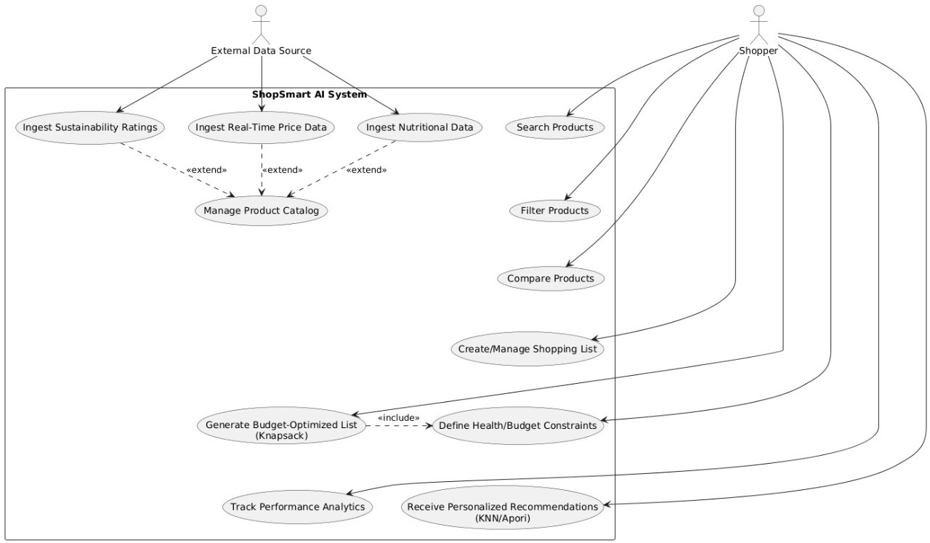
Figure 5.1: Use-Case Diagram

Actors:
- Shopper: Represents the primary user who interacts with the system to search for products, manage their shopping list, set constraints, and receive intelligent, optimized recommendations.
- System Administrator: Represents the user responsible for maintaining the system's operational integrity and manually managing/verifying the product catalog.
- External Data Source: Represents external systems or APIs that supply critical, regularly updated data to the system, such as price feeds, nutritional information, and eco-ratings.
Use Cases:
- Search Products: Allows the Shopper to find items using keywords, brand names, or categories.
- Filter Products: Enables the Shopper to narrow down search results based on multiple criteria, including price range, nutrition targets, and sustainability scores.
- Compare Products: Allows the Shopper to view side-by-side comparisons of selected products based on price, nutritional value, and sustainability ratings.
- Create/Manage Shopping List: Enables the Shopper to add, remove, and modify items on their intended purchase list.
- Define Health/Budget Constraints: Allows the Shopper to set explicit restrictions, such as a maximum total budget, specific allergen rules, or dietary goals (e.g., low-sugar, high-protein).
- Receive Personalized Recommendations (KNN/Apriori): Provides the Shopper with spontaneous, supplementary suggestions based on their historical purchasing behavior (KNN) or general market basket analysis (Apriori).
- Generate Budget-Optimized List (Knapsack): The core intelligence feature that takes the Shopper's list and constraints, and uses the Knapsack algorithm to recommend the highest-value selection of items that still adheres to the defined budget.
- Track Performance Analytics: Displays the Shopper’s post-purchase analysis, including savings achieved, cumulative nutritional impact, and overall environmental footprint.
- Manage Product Catalog: Allows the System Administrator to verify, update, and maintain the integrity of all product entries in the central database.
- Ingest Real-Time Price Data, Ingest Nutritional Data, Ingest Sustainability Ratings: Core data ingestion processes performed by the system using the External Data Source.
Relationships:
- Association: Connects the Shopper actor with all user-facing use cases, and the System Administrator and External Data Source actors with their relevant data management and ingestion tasks.
- Include Relationship:
  - Generate Budget-Optimized List (Knapsack) <<include>> Define Health/Budget Constraints: This is a mandatory relationship because the optimization process cannot be executed without applying the user's explicit rules and budget limits.
- Extend Relationships:
  - Ingest Real-Time Price Data, Ingest Nutritional Data, Ingest Sustainability Ratings <<extend>> Manage Product Catalog: These ingestion processes are optional steps that extend the functionality of maintaining the Product Catalog by automatically feeding it external, updated data.

5.2 DFD (Data Flow Diagram):
The Data Flow Diagram (DFD) for the ShopSmart AI project (Fig. 5.2) visually illustrates how data is acquired, processed, and transformed within the system to achieve the core objective of generating optimized shopping recommendations. This diagram details the movement of information between External Entities (like the Shopper and Price Feeds), internal Processes (such as Data Ingestion and the Hybrid Recommendation Engine), and Data Stores (the Product Catalog and User History). It clearly maps the flow from raw price and nutritional data through to the final output of an optimized basket and performance analytics dashboard.
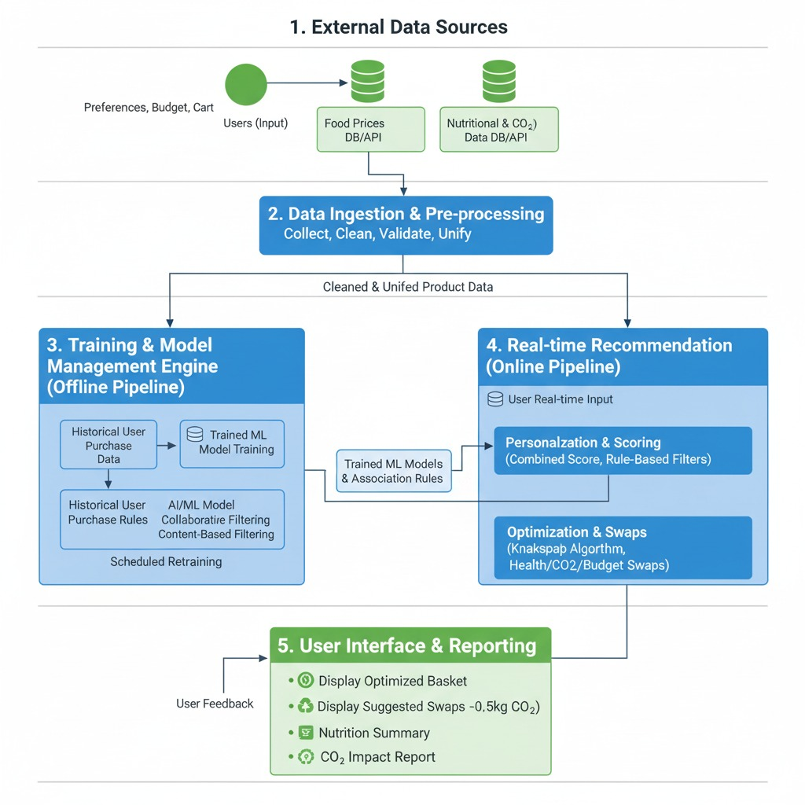
Figure 5.2: Data Flow Diagram

User Interaction:
- Users engage with learning resources from a comprehensive database Users interact with and consume a wide array of educational resources, including expert-curated notes, interactive quizzes, and full-length mock exams, available within the platform.
Data Collection:
- User engagement data (user id, resource id, action type, timestamp) are collected The system records comprehensive user engagement data with learning resources, including the unique user ID, resource ID, the type of action performed (e.g., attempt, complete, view), and the timestamp of the interaction.
- Integration with external educational databases via APIs The system employs robust API integrations to connect with external educational databases, ensuring the collection of the latest syllabus updates and resource content.
Article/Resource Data Preprocessing:
- Text cleaning and content feature extraction The textual data from learning resources (notes, question text, solution explanations) is cleaned by removing irrelevant characters, tokenization, and normalizing text features.
- TF-IDF calculation Term Frequency-Inverse Document Frequency (TF-IDF) scores are calculated for the resources based on their textual content, representing the importance of specific concepts or terms relative to the entire educational corpus.
- TF-IDF matrix creation A TF-IDF matrix is created as a numerical representation of the resources, which captures the content-based features used for similarity calculation.
User Data Processing:
- Normalization of user engagement data using MinMaxScaler The collected user engagement data (e.g., quiz scores, completion rates, view frequency) is normalized using a MinMaxScaler technique to scale the data to a consistent range (e.g., 0 to 1), ensuring fair comparison.
- Calculation of user cosine similarity scores Based on the normalized engagement data, user-cosine similarity scores are calculated to accurately measure the similarity between different users based on their shared learning patterns and resource consumption.

Filtering Approaches:
- Collaborative filtering based on user similarities This approach recommends resources that have been favorably engaged with by users deemed most similar, leveraging the user cosine similarity scores calculated in the previous step.
- Content-based filtering based on item (resource) similarities This approach recommends new resources whose content is similar to the resources a user has previously engaged with, based on the resource content similarities calculated from the TF-IDF matrix.
Hybrid Model:
- Combination of collaborative and content-based filtering A hybrid recommendation model is engineered by combining the outputs of both collaborative filtering and content-based filtering, allowing the system to consider both the wisdom of the crowd (user similarities) and the intrinsic nature of the content (resource similarities).
Recommendation Generation:
- Top resource recommendations from the hybrid model The sophisticated hybrid model generates a prioritized list of top learning resource recommendations, effectively tailoring a structured learning path for each student to address their strengths and weaknesses.
Result Display:
- Recommended resources displayed to users The recommended learning resources are presented to the students through the user-friendly interface, appearing prominently on their dashboard or within their personalized study plans.

5.3 System Architecture:
The provided image (Fig 5.3) outlines the System Architecture for ShopSmart AI, detailing the flow from user input to the final optimized output. The architecture is fundamentally a hybrid system designed for data processing and intelligent optimization, integrating user-defined constraints with machine learning algorithms. The flow begins with Input (Budget, Diet, Preferences, History) which feeds into the Data Processing layer. This layer utilizes algorithms like Association Rules and K-Nearest Neighbors (KNN) to generate item suggestions. All processed data is then synthesized by the Hybrid Model to produce an Optimized Grocery Basket as the final Output, incorporating constraints related to budget, health, swaps, and impact.

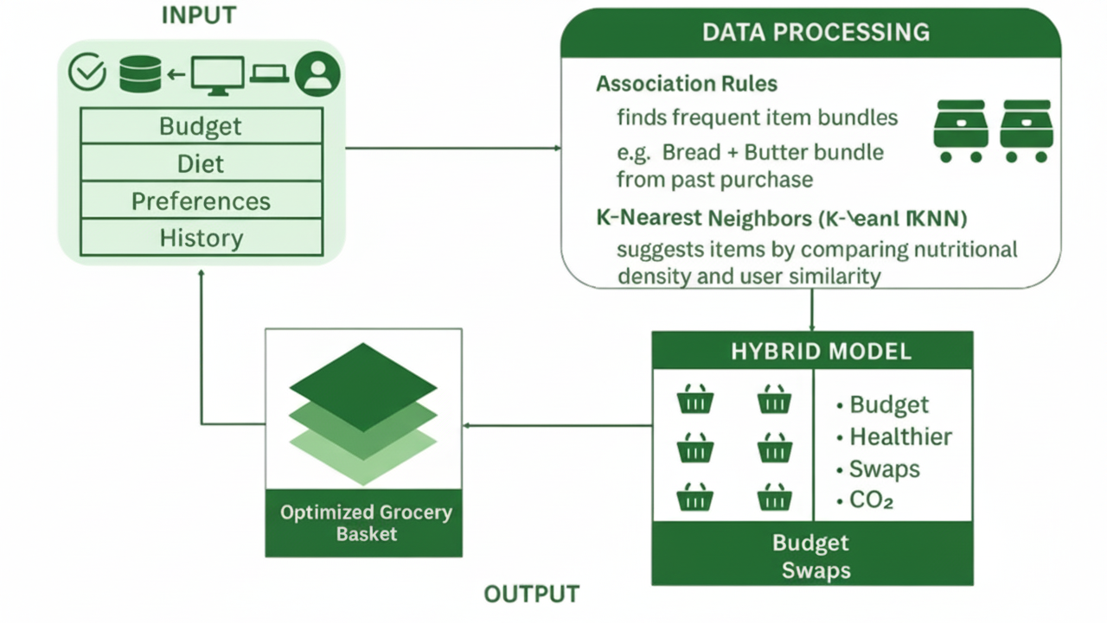
Figure 5.3: System Architecture

Data Collection and Ingestion:
- External Data is collected using API feeds and specialized ingestion tools: The system connects to various external sources to gather multi-dimensional data. Real-time Price Data, Nutritional Data, and Sustainability Ratings are ingested via dedicated API feeds or robust web scraping processes (as outlined in the DFD).
- User interactions and constraints are collected and stored: The platform continuously records user purchase history, explicit preferences, budget limits, and dietary constraints.
Data Preprocessing and Unification:
- Product Data unification and cleaning: Raw price data, nutritional facts, and sustainability scores are collected and preprocessed to standardize formats, handle missing values, and ensure consistent linkage across the central product catalog.
- User interaction data processing: Historical user purchase data is cleaned to remove duplicates and format timestamps, preparing it for collaborative filtering analysis.
Feature Engineering:
- Nutritional Density and Value Scoring: Instead of TF-IDF, the system generates value-based features for each product. A composite score for Nutritional Density (e.g., protein per dollar) and a weighted Sustainability Score are generated to represent the intrinsic value of the item, which is a key input for the Knapsack algorithm.
- Categorical Encoding for Item Similarity: Product categories, brands, and types are encoded into numerical vectors (e.g., one-hot or embedding vectors) for use in content-based similarity comparisons.
Normalization and Matrix Creation:
- Interaction scores normalization: User-item interaction scores (e.g., purchase frequency, rating) are normalized using MinMaxScaler to scale the data to a common range for fair comparison in collaborative filtering.
- User-Item Interaction Matrix Creation: A matrix is created to represent user-product purchase history, which is then converted to a sparse matrix for efficient computation by the KNN model.

Similarity and Scoring:
- Content-Based Similarity: Model computes similarity scores based on product category vectors and nutritional profile vectors using a linear kernel (cosine similarity).
- Value-Based Scoring: The system calculates a cost-per-value metric for the Knapsack optimization, comparing the price of an item against its engineered Nutritional Density and Sustainability Score.
User Similarity Matrix:
- A User Similarity Matrix is computed based on historical interactions using pairwise distances (e.g., Cosine Similarity or Adjusted Cosine Similarity) to identify groups of users with similar purchasing patterns.
Recommendation and Optimization Functions:
- get_collaborative_recommendations (KNN/Apriori): This function utilizes the user similarity matrix to identify the most similar users and aggregates their purchases to recommend products the target user is likely to be interested in (KNN) or recommends product bundles frequently bought together (Apriori).
- get_rule_based_filtering: This function acts as a pre-filter, strictly enforcing user-defined dietary and health constraints to eliminate non-compliant products before the final optimization step.
- get_knapsack_optimization: The core function that takes the rule-filtered list, the user's budget constraint, and the item's cost-per-value score to select the final highest-value combination of products that fits precisely within the budget.
- get_hybrid_recommendation: Combines the outputs of the Knapsack Optimization (constraint-based) with the Collaborative Recommendations (preference-based) to provide the final optimized list, removing duplicates and presenting the top hybrid recommendations.
- Evaluation Metrics: Accuracy metrics (precision, recall, F1-score) are computed to evaluate the performance of the collaborative model, while the Budget Adherence and Value Maximization Score (VMS) metrics are used to evaluate the optimization efficiency.

5.4 Implementation:
The Implementation phase of the ShopSmart AI project demonstrates the effectiveness of the proposed hybrid recommendation and optimization system. The hybrid architecture, which integrates collaborative filtering, rule-based constraints, and the Knapsack optimization algorithm, achieves significant improvements in key metrics compared to individual techniques. The success of the implementation is quantitatively validated using metrics such as Budget Adherence, Value Maximization Score (VMS), and Precision all of which indicate the system's ability to make relevant, personalized, and budget-optimized grocery recommendations for users.

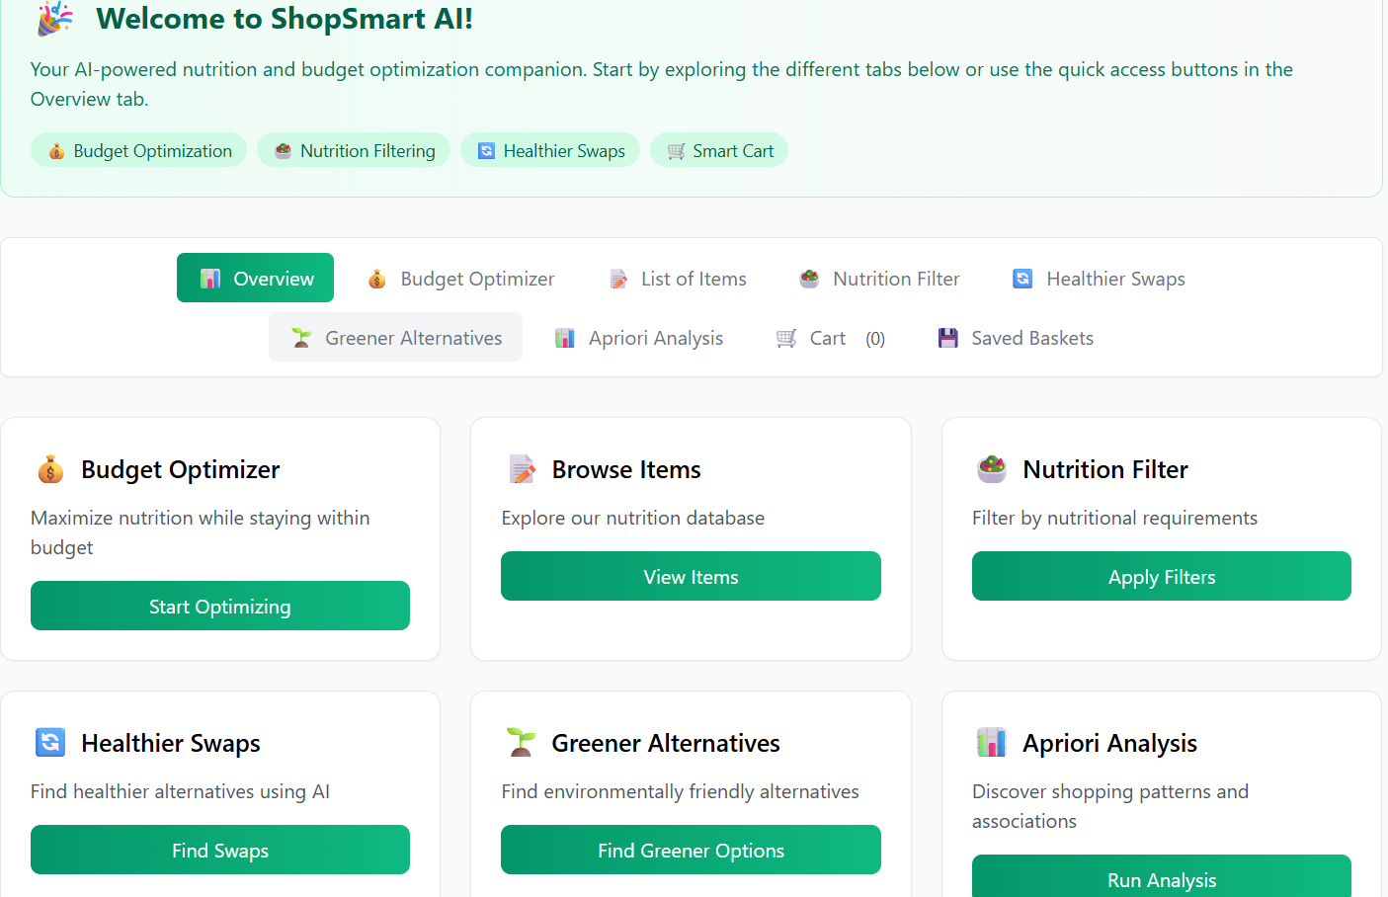
Figure 5.4.1: Dashboard

The above Figure 5.4.1 displays the Welcome to ShopSmart AI dashboard, presenting the user interface as an AI-powered nutrition and budget optimization companion. The main screen, labeled "Overview," organizes the system's core functionalities into a series of large, accessible cards and a primary navigation menu. Key features are prominently displayed, including the Budget Optimizer, which promises to maximize nutrition while staying within budget; Browse Items, allowing exploration of the nutrition database; and the Nutrition Filter, enabling users to apply specific nutritional requirements. Additionally, the dashboard highlights advanced, AI-driven tools: Healthier Swaps for finding healthier alternatives, Greener Alternatives for finding environmentally friendly options, and Apriori Analysis for discovering shopping patterns and associations. The interface, characterized by its clean, card-based layout and green call-to-action buttons, is designed to provide immediate access to the system's powerful optimization and filtering capabilities.

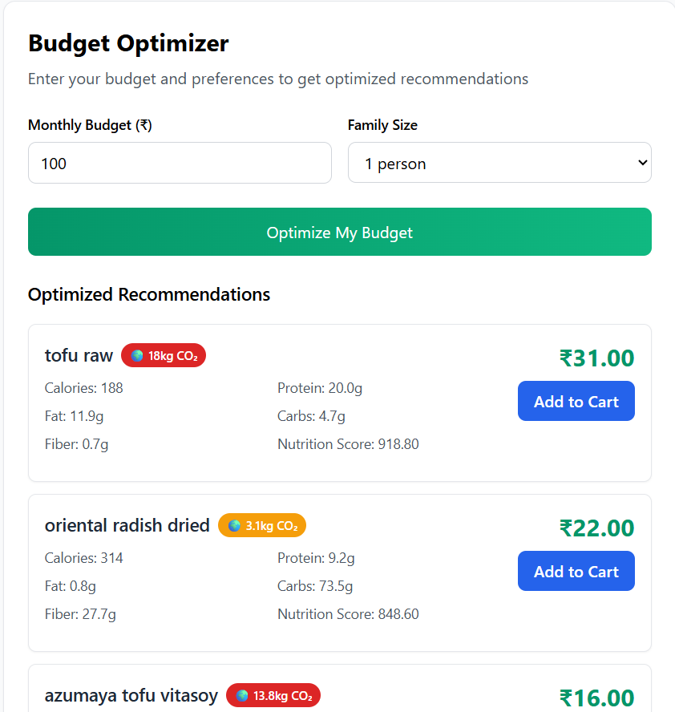
Figure 5.4.2: Budget Optimizer

The above Figure 5.4.2 displays the Budget Optimizer page for the ShopSmart AI application, designed to provide users with product recommendations that maximize nutritional value within a defined budget. The user is first prompted to enter their constraints, specifically a Monthly Budget (INR), shown here as 100, and their Family Size, which is set to 1 person. Once these inputs are entered, the user clicks the prominent green button labeled "Optimize My Budget" to initiate the recommendation process. The subsequent output section, clearly titled "Optimized Recommendations", displays the results generated by the system. The recommendations are presented in clean, individual cards, with each card providing a comprehensive overview of a recommended product, including its Product Name (e.g., tofu raw), its Price (e.g., 31.00), and an "Add to Cart" button. Crucial features include a colored bubble indicating the Environmental Impact (e.g., for tofu raw) and detailed Nutritional Metrics such as Calories, Fat, Fiber, Protein, Carbs, and a composite Nutrition Score. This page demonstrates the critical function of the system by integrating budget, family size, price, nutrition, and sustainability data to deliver an optimized shopping solution.

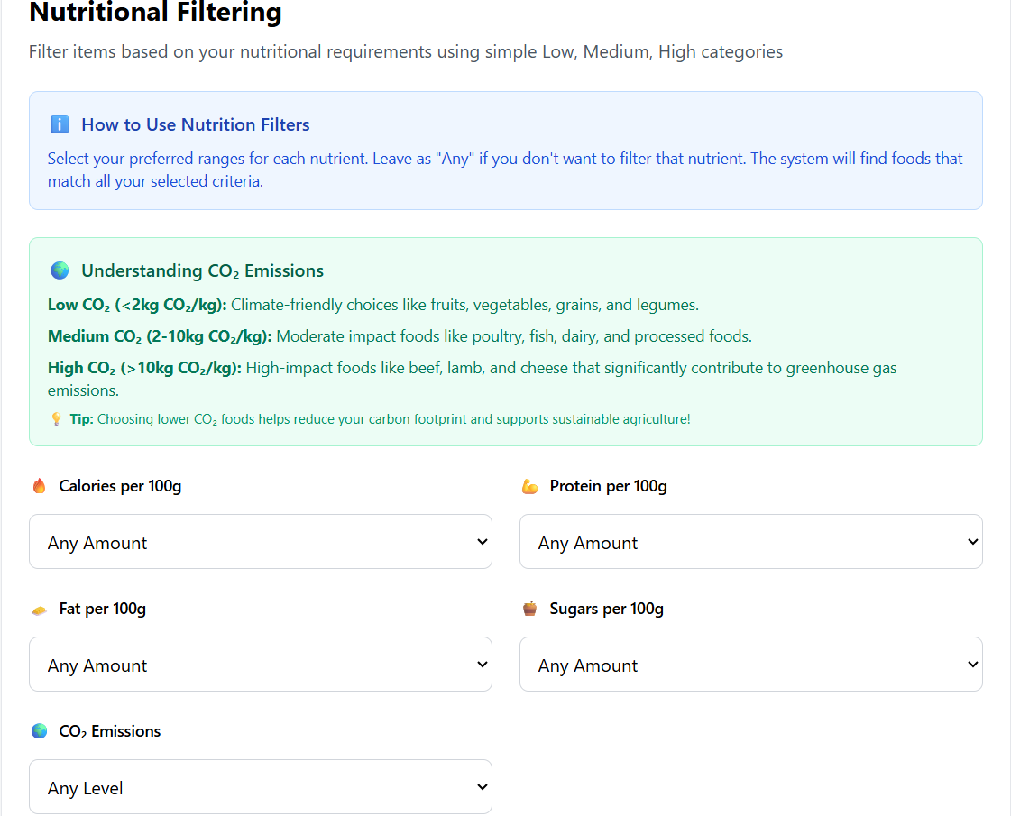
Figure 5.4.3: Nutritional Filtering

The above Figure 5.4.3 displays the Nutritional Filtering page of the ShopSmart AI application, which allows users to filter items based on their nutritional and environmental requirements using predefined categories. The interface is highly instructional, offering a "How to Use Nutrition Filters" section that advises users to select their preferred ranges for each nutrient or leave the field as "Any" if no filter is desired. A dedicated section titled "Understanding Emissions" provides clear definitions for the Low CO2 (<2kg CO2/kg), Medium CO2 (2-10kg CO2/kg), and High CO2 (>10kg CO2/kg) categories, with a tip encouraging users to choose lower CO2 foods. Below this guidance, the main filtering interface provides dropdown menus for setting ranges for key metrics, including Calories per 100g, Protein per 100g, Fat per 100g, Sugars per 100g, and Emissions, with all fields currently set to the default "Any Amount" or "Any Level". This page directly implements the system's objective of enhancing decision-making by integrating both health and environmental constraints.

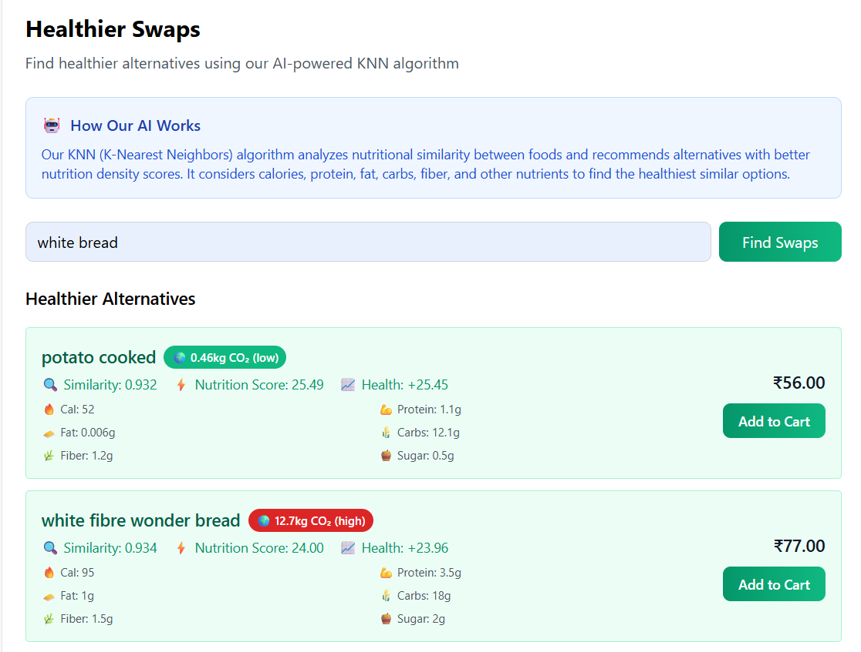
Figure 5.4.4: Healthier Swaps

The Above Figure 5.4.4 displays the Healthier Swaps feature of the ShopSmart AI application, which utilizes an AI-powered KNN (K-Nearest Neighbors) algorithm to suggest better alternatives for a user-specified item. The page includes an introductory box explaining "How Our AI Works," detailing that the KNN algorithm analyzes the nutritional similarity between foods to recommend alternatives with better nutritional density scores by considering calories, protein, fat, carbs, and fiber. The input field shows the user searching for swaps for "white bread," and clicking "Find Swaps" generates the results. The output section, labeled "Healthier Alternatives," displays suggested products like "potato cooked" and "white fibre wonder bread" in separate cards. Each alternative is detailed with a Similarity score (indicating how close it is to the original item), a Nutrition Score, a Health score, and full nutritional breakdown, along with its CO2 emission and price, allowing the user to make a health-optimized choice.

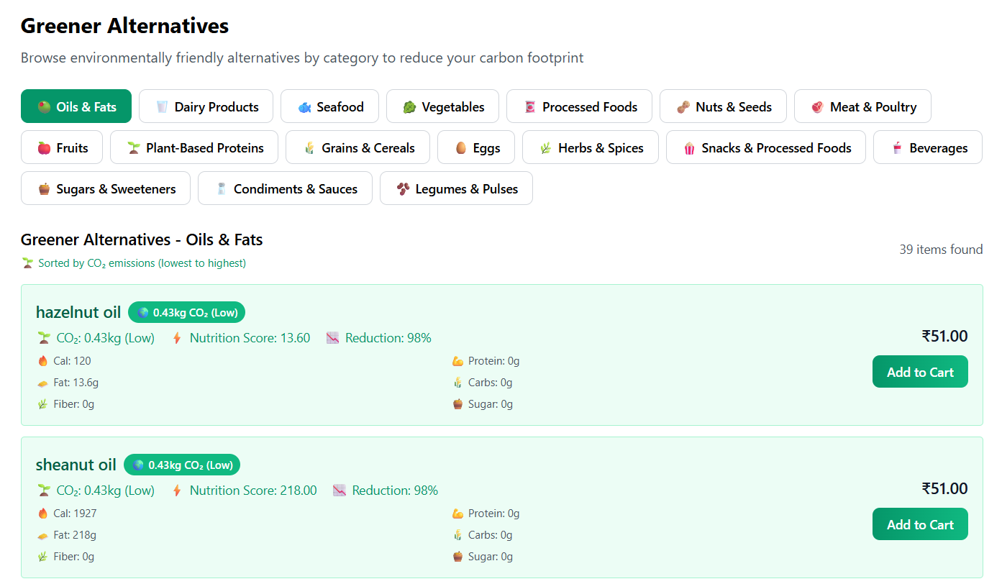
Figure 5.4.5: Greener Alternative

The above Figure 5.4.5 displays the Greener Alternatives page of the ShopSmart AI application, which enables users to browse environmentally friendly product swaps by category to reduce their carbon footprint. The interface features a prominent set of horizontal tabs allowing the user to select a product category, with the "Oils & Fats" category currently selected and highlighted. Below the category tabs, the results section, labeled "Greener Alternatives - Oils & Fats", indicates that 39 items were found and confirms that the list is sorted by CO2 emissions from lowest to highest. The product results are displayed in cards, showcasing alternatives like hazelnut oil and sheanut oil. Each listing provides comprehensive data crucial for conscious purchasing: the CO2 emission (e.g., and a "Low" classification), a Nutrition Score, a Reduction percentage (e.g., 98%reduction), calorie and nutrient breakdowns, and the price (INR 51.00), along with an "Add to Cart" option.

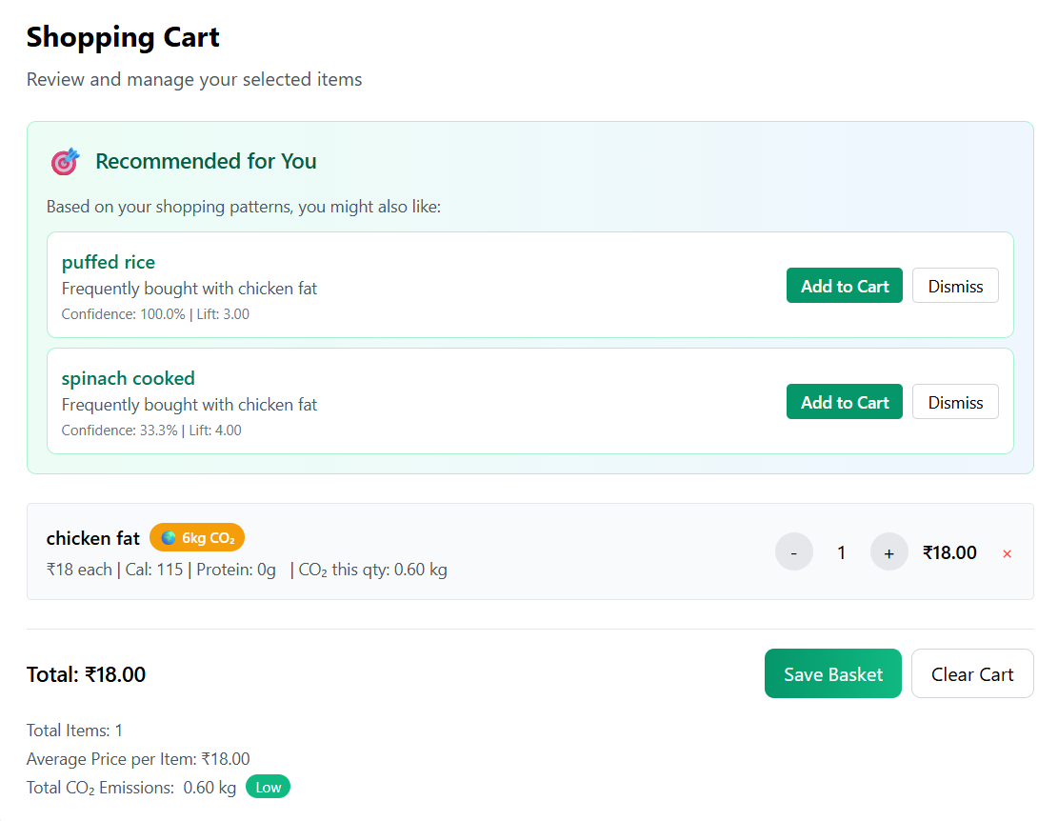
Figure 5.4.6: Shopping Cart

The above Figure 5.4.6 displays the Shopping Cart review and management page, which incorporates real-time analytics and personalized recommendations based on the user's current selections. The primary feature is the "Recommended for You" section, which uses association rule mining (Apriori) to suggest "puffed rice" and "spinach cooked" based on them being frequently bought with the item already in the cart, "chicken fat". This section provides key metrics like Confidence and Lift for each suggestion, along with easy "Add to Cart" and "Dismiss" buttons. Below this, the cart details show that the user has selected one unit of "chicken fat," priced at INR18.00, and displays its individual emission (6kg CO2) and nutritional data. The footer summarizes the order: the Total price is INR18.00, and the calculated Total CO2 Emissions are 0.60 kg, which is categorized as Low. The user can finalize the purchase using the "Save Basket" or "Clear Cart" buttons.

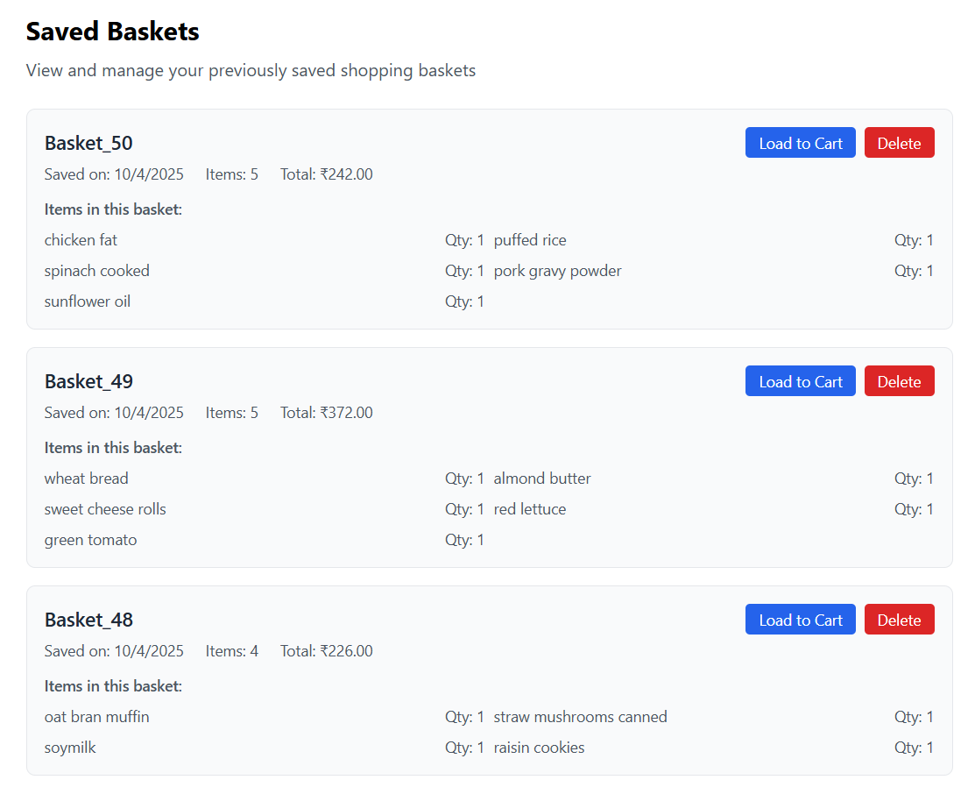
Figure 5.4.7: Saved Basket

The above Figure 5.4.7 displays the Saved Baskets management page for the ShopSmart AI application, allowing the user to view and manage their previously stored shopping baskets. The interface lists multiple saved baskets, such as Basket_50, Basket_49, and Basket_48, with each entry providing key summary details. These details include the date saved (all shown as ), the number of items, and the Total price (e.g., for Basket_50). Each card clearly lists the Items in this basket, showing the name and quantity for every saved product (e.g., "chicken fat," "sunflower oil," and "puffed rice" in Basket_50).

Chapter 6
Technical Specification

The technical specifications for the ShopSmart AI project define the foundational hardware, software, methodologies, and data resources required for its development and operational success. These choices are tailored to ensure the platform is compatible, scalable, and efficient in delivering intelligent and personalized grocery recommendations.

- Hardware Requirements:-
The system's core operation, being a web-based platform primarily focused on data processing and recommendations, is more reliant on server-side computational power than specialized local hardware.
- Development/Testing Environment:
  - CPU: Multi-core processor (e.g., Intel Core i5/i7 or equivalent) for efficient model training and local testing.
  - RAM: Minimum 8GB RAM (16GB recommended) for handling the large product dataset and running the machine learning models locally.
  - Storage: Solid State Drive (SSD) for fast data access, which is crucial for handling frequent database interactions and rapid model loading.
- Deployment/Production Environment (Cloud-Based):
  - Virtual Machines (VMs): Scalable cloud instances (e.g., on AWS or Azure) with auto-scaling capabilities to manage varying user load.
  - Database Server: Dedicated server instance (e.g., AWS RDS or Azure Database) optimized for high-volume read/write operations for MySQL.

- Software Requirements:-
The core software for ShopSmart AI is the Python 3.x language and its ecosystem, utilizing the lightweight Flask framework for the backend and MySQL for robust data storage. Development will use PyCharm, with the final deployment targeting Linux for optimal scalability and security.
- Operating System (OS): Windows 10 and Above for local development; Linux (e.g., Ubuntu, CentOS) for cloud deployment due to its stability, security, and superior support for Python and web server technologies.
- Integrated Development Environment (IDE): PyCharm (Professional Edition recommended) for efficient Python development, debugging, and data science integration.
- Programming Language: Python 3.x (latest stable version recommended, e.g., 3.10+) for the backend, machine learning models, and scripting.
- Backend Framework: Flask for rapid, lightweight API and web service development.
- Database Management System (DBMS): MySQL for robust, scalable, and transactional data storage of all product, user, and transaction data.
- Frontend Technologies: HTML, CSS, and JavaScript for the responsive user interface.
- Key Python Libraries:
  - Scikit-learn: For implementing and evaluating traditional machine learning algorithms like KNN and Rule-Based methods.
  - NumPy and Pandas: For efficient numerical computation and data manipulation/preprocessing of the large product dataset.
  - MLXTEND: For implementing the Apriori algorithm for association rule mining.
  - Pulp (or similar solver library): To model and solve the Knapsack Algorithm for budget optimization.
  - MySQL Connector/SQLAlchemy: For reliable Python Database Connectivity to MySQL.

- Methodology
The system’s intelligence is derived from a hybrid recommendation approach, combining multiple methodologies to provide a holistic solution.
- Hybrid Recommendation Strategy: The system utilizes a combination of models to provide personalized, constraint-aware, and value-maximized recommendations.
- KNN (K-Nearest Neighbors): Used for the Collaborative Filtering component to suggest items based on user similarity.
- Apriori Algorithm: Used for Association Rule Mining to generate product bundling suggestions (e.g., frequently bought together).
- Knapsack Algorithm: Used as an Optimization Method to process the user's shopping list against their budget constraint to recommend the highest-value (e.g., most nutritious/sustainable) combination of items that fits the budget.
- Rule-Based Filtering: Used to enforce hard constraints, such as ensuring all recommendations adhere to a user's dietary or health rules (e.g., "low-sugar only").

- Datasets
The operational viability and accuracy of the ShopSmart AI platform depend on the integration and maintenance of comprehensive, multi-faceted datasets.
- Product Catalog: A diverse collection of grocery items with essential attributes (Name, Brand, Category, Size).
- Price Data: Regularly updated list of prices linked to the product catalog across various retailers.
- Nutritional Database: Detailed, verified nutritional information (e.g., calories, fat, protein, sugar) for each product.
- User/Transaction Data: Historical data on user purchases, ratings, and dietary constraints (used to train KNN and Apriori models).
- Sustainability Classification Data: A dataset providing eco-ratings or classifications for products.
Chapter 7
Project Scheduling

Project scheduling is a crucial aspect of effective project management, providing a roadmap for the timely completion of tasks and milestones within a defined timeframe. To visualize this schedule, a Gantt chart is employed, providing a graphical representation of task durations, start and finish dates, and interactivity. Additionally, Gantt charts help illustrate the project's work breakdown structure and the relationships between activities, ensuring effective project management and progress tracking. The detailed explanation of the Gantt chart for ShopSmart AI is explained below after Figure 7.1.

To visualize this schedule, a Gantt chart is employed, providing a graphical representation of task durations, start and finish dates, and interactivity. Additionally, Gantt charts help illustrate the project's work breakdown structure and the relationships between activities, ensuring effective project management and progress tracking.

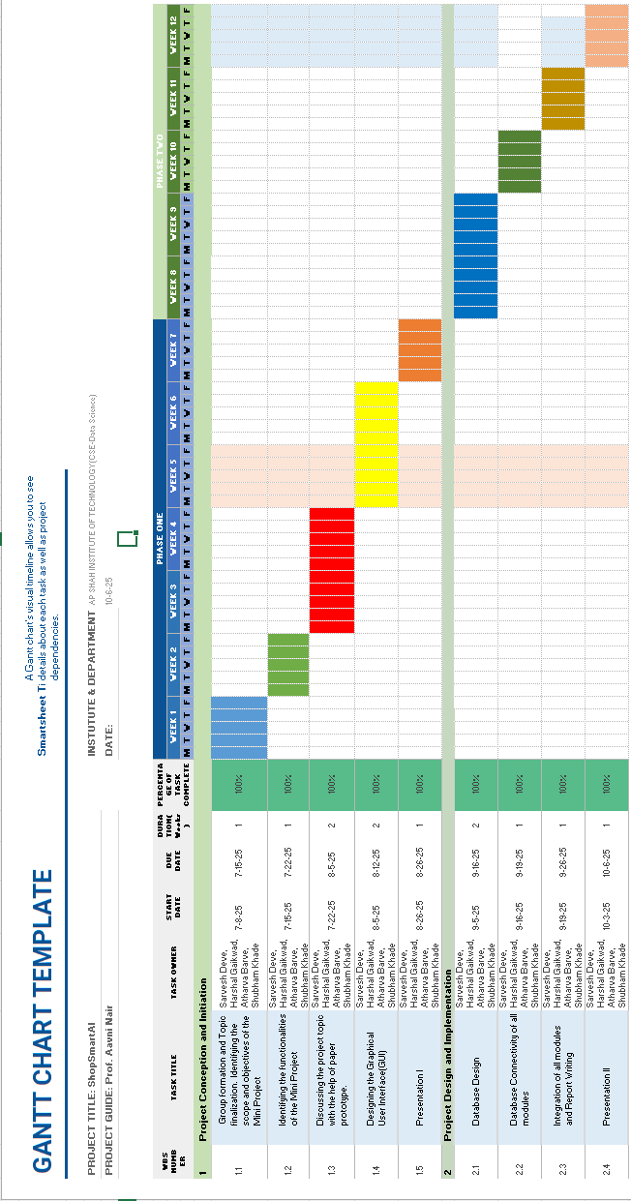
Figure 7.1: Gantt chart for ShopSmartAI

The Project Conception and Initiation phase (WBS 1.1 to 1.5) was executed across the first seven weeks of the schedule. The initiation began with Group formation and Topic finalization, identifying the scope and objectives of the Mini Project (WBS 1.1), which was performed by the team from 7-6-25 to 7-18-25. Following this, the task of Identifying the functionalities of the Mini Project (WBS 1.2) was successfully completed in the same month, running from 7-22-25 to 7-25-25. The subsequent task, Discussing the project topic with the help of paper prototype (WBS 1.3), was completed in the following month between 8-22-25 and 8-25-25. The design element of the project, Designing the Graphical User Interface (GUI) (WBS 1.4), was a two-week effort spanning from 9-02-25 to 9-12-25. This entire initiation phase culminated in the completion of Presentation I (WBS 1.5) between 9-26-25 and 9-28-25.

The Project Design and Implementation phase (WBS 2.1 to 2.4) concurrently began with the foundational technical work. Database Design (WBS 2.1) was performed from 9-5-25 to 9-16-25. This critical design task was immediately followed by the task of Database Connectivity of all modules (WBS 2.2), which occurred from 9-18-25 to 9-19-25. The integration milestone, Integration of all modules and Report Writing (WBS 2.3), was executed between 9-26-25 and 9-28-25, ensuring the project deliverables were finalized simultaneously with the first presentation. The entire project schedule is marked for completion with the final task, Presentation II (WBS 2.4), scheduled from 10-3-25 to 10-6-25.

Chapter 8
Results

The project results section provides a concise overview of the outcomes achieved through the implementation of the ShopSmart AI platform, highlighting key findings, deliverables, and the final impact on the user's shopping experience.
The below Figure 8.1 displays a pie chart titled "Category-wise Contribution", which visually segments the total carbon dioxide emissions (or carbon footprint) attributed to different food categories in a consumer's basket or a general food system.

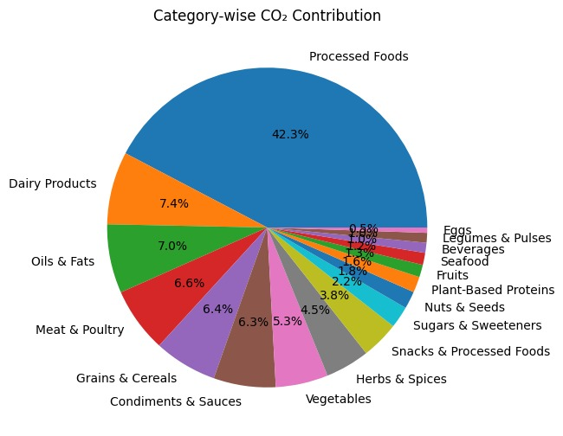
Figure 8.1: Category-wise Contribution

The pie chart illustrates the relative contribution of various food groups to the total CO2 equivalent emissions, highlighting the disparity in environmental impact across different product categories. The largest segment by a significant margin is Processed Foods, which accounts for a substantial 42.3% of the total CO2 contribution, indicating that industrial processing and complex supply chains are the primary drivers of the carbon footprint.
Following this, several major food groups also contribute significantly. Dairy Products account for 7.4%, Oils & Fats contribute 7.0%, Meat & Poultry stands at 6.6%, Grains & Cereals add 6.4%, Condiments & Sauces contribute 6.3%, and Vegetables make up 5.3%. These categories collectively represent over 39% of the contribution, underscoring the substantial impact from the production and transportation of primary ingredients and their components.
The remaining categories individually contribute less than to the total footprint. These include Herbs & Spices (4.5%), Snacks & Processed Foods (3.8%), and Sugars & Sweeteners (2.2%) which represent contributions from specialty ingredients and indulgences. Categories typically associated with a lower environmental footprint, such as Fruits (1.8%), Plant-Based Proteins (1.6%), Seafood (1.3%), Beverages (1.0%), Legumes & Pulses (0.6%), and Eggs (0.5%), form the smallest wedges of the chart. In summary, the chart strongly suggests that efforts to reduce the carbon footprint of a diet should primarily focus on minimizing the consumption of Processed Foods, given its disproportionate contribution, followed by impacts across high-volume staples like Dairy, Meat, and Grains.

The below Figure 8.2 is a scatter plot titled "Price vs Emission Trade-off", illustrating the relationship between the price of products (on the x-axis) and their corresponding CO2 emissions in kilograms of CO2 equivalent (kg CO2e, on the y-axis).

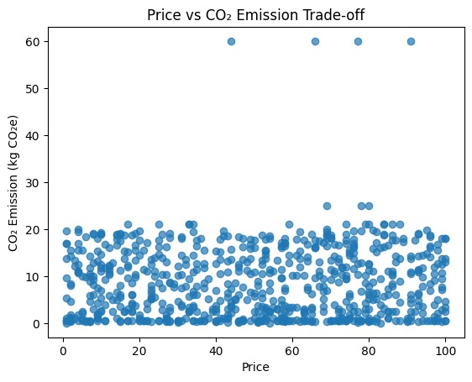
Figure 8.2: Price vs Emission Trade-off

This scatter plot visualizes the distribution of products based on two key metrics: price and environmental impact, highlighting the correlation and trade-offs present in the dataset.
The majority of the data points are densely clustered at the lower range of CO2 emissions, primarily between 0 and 20 kg CO2e, and distributed across the entire price range from 0 to 100 (presumably currency units). This heavy clustering suggests that most products in the catalog have relatively low carbon footprints, regardless of their cost.
Crucially, the chart reveals a distinct vertical stratification in the data:
- Low Emission Cluster: The vast majority of items fall within the 0 to 20kg CO2e band. The density of points here indicates no clear correlation between price and emission for most products; a cheap item is just as likely to have low emissions as an expensive one. This suggests that for typical groceries, the environmental cost doesn't necessarily dictate the monetary cost.
- High Emission Outliers: A small, but significant, group of data points are clustered near the maximum emission level of 60kg CO2e. These items appear at intermittent high price points, specifically around price units 45, 65, 75, and 95. These points represent high-emission outliers that command a premium price, indicating instances where both the environmental and monetary costs are exceptionally high.

The blow Figure 8.3 image displays a horizontal bar chart titled "Top 10 High-CO2 Items", illustrating the individual CO2 emissions (in kg CO2e) for the ten products with the highest carbon footprint in the dataset.

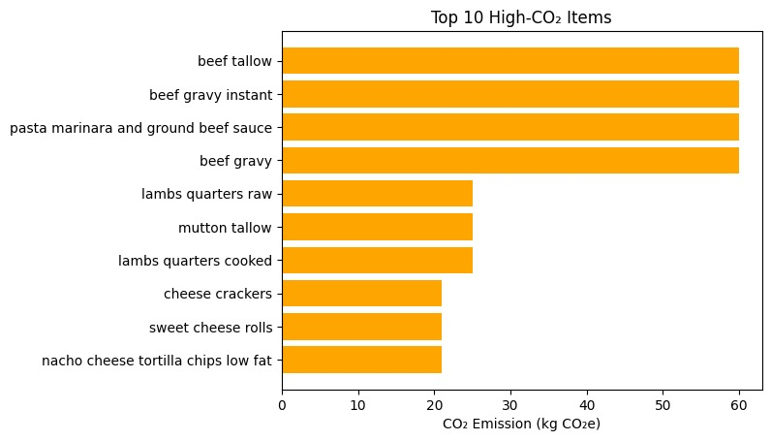
Figure 8.3: Top 10 High-CO2 Items

This bar chart clearly identifies the specific items driving the highest carbon emissions within the catalog, emphasizing the dominant role of beef and beef-related processed foods. The top four items all exhibit emissions at or near the maximum recorded level of 60kg CO2e. These four highest-emitting items are: beef tallow, beef gravy instant, pasta marinara and ground beef sauce, and beef gravy. The immediate dominance of these processed and raw beef products underscores that efforts to reduce the basket's carbon footprint must focus heavily on this category.
The next tier of high-impact items includes other meats and tallows, such as lambs quarters raw, mutton tallow, and lambs quarters cooked, all clustered around the 25 kg CO2e mark. This confirms that meat products, particularly beef and lamb, represent a category of uniformly high environmental cost.
Finally, three specific processed snack items round out the top ten, all showing emissions just over 20 kg CO2e. These items are cheese crackers, sweet cheese rolls, and nacho cheese tortilla chips low fat. Their presence indicates that even certain non-meat processed snacks can have a disproportionately high environmental impact, likely due to dairy content, complex manufacturing, or packaging.

The below Figure 8.4 contains two line graphs side-by-side, titled "Execution Time Comparison" and "Recommendation Accuracy Comparison", which collectively evaluate the performance of five different algorithms (KNN, Decision Tree, Popularity-based, Apriori, and Naive Co-occurrence) across varying dataset sizes.

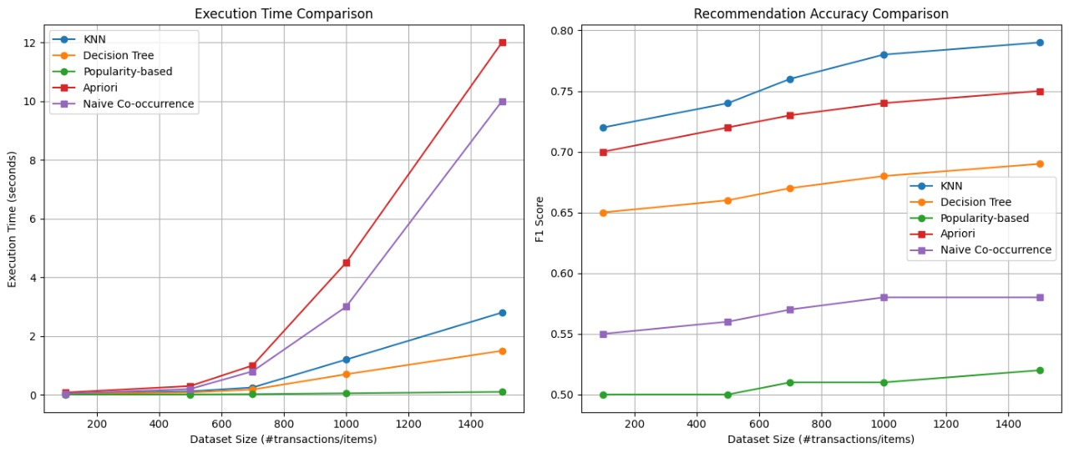
Figure 8.4: Execution Time Comparison and Recommendation Accuracy Comparison

The two graphs provide a comprehensive evaluation of five recommendation algorithms based on their computational efficiency and predictive quality as the size of the input dataset increases.
- Execution Time Comparison
The graph on the left, titled Execution Time Comparison, measures the time (in seconds) required for each algorithm to process datasets ranging from 200 to 1500 transactions/items.
- Fastest Algorithms: Decision Tree and Popularity-based models exhibit the lowest execution times, remaining close to the x-axis (near 0 seconds) even as the dataset size reaches 1500. Their computation time scales negligibly with data volume.
- Moderate Growth: KNN shows a linear and manageable increase in execution time, reaching approximately 2.8 seconds at the largest dataset size.
- Slowest Algorithms: Apriori and Naive Co-occurrence show significantly steep, non-linear growth in execution time. Apriori is the slowest overall, skyrocketing to over 12 seconds, while Naive Co-occurrence closely follows, peaking at around s10 seconds. This rapid growth suggests that these algorithms struggle the most with scalability and computational cost as the data volume increases.
- Recommendation Accuracy Comparison
The graph on the right, titled Recommendation Accuracy Comparison, evaluates the predictive quality of the same five algorithms using the F1 Score, across the same range of dataset sizes.
- Highest Accuracy: KNN consistently maintains the highest F1 Score, starting near 0.72 and peaking close to 0.78 at the largest dataset size.
- Strong Performance: Apriori also demonstrates strong, competitive performance, starting just under 0.70 and achieving an F1 Score of approximately at the largest size.
- Moderate Accuracy: Naive Co-occurrence shows moderate and increasing accuracy, growing from 0.55 to about 0.58.
- Lower Accuracy: Decision Tree and Popularity-based algorithms consistently show the lowest accuracy. The Popularity-based model remains flat at an F1 Score of 0.50, indicating poor personalization, while Decision Tree shows modest growth from 0.65 to nearly 0.70, but remains significantly behind KNN and Apriori.

The below Figure 8.5 is a horizontal bar chart titled "Total Spending by Product Category", which ranks various food categories based on the total monetary amount spent (in ₹) on each category.
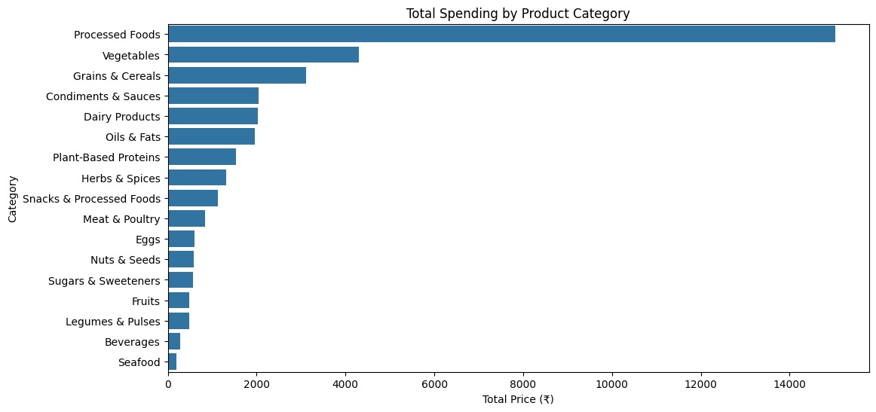
Figure 8.5: Total Spending by Product Category
This bar chart clearly illustrates the spending habits of consumers, ranking product categories from highest to lowest total expenditure, which is crucial for the ShopSmart AI's budget and optimization features. The chart immediately highlights the dominance of Processed Foods, which command the highest expenditure by a significant margin, with total spending exceeding ₹14,000. This immense spending on processed items suggests a strong need for budget optimization in this area.
The second and third highest spending categories are Vegetables, with total spending exceeding ₹4,000, and Grains & Cereals, with expenditure around ₹3,000. These are followed by a dense mid-range cluster of categories with spending between approximately ₹1,500 and ₹2,500, including Condiments & Sauces, Dairy Products, Oils & Fats, Plant-Based Proteins, Herbs & Spices, and Snacks & Processed Foods.
Spending then drops sharply for the remaining categories, which constitute the lower end of the expenditure spectrum. This bottom cluster, including Meat & Poultry, Eggs, Nuts & Seeds, Sugars & Sweeteners, Fruits, Legumes & Pulses, Beverages, and Seafood, all exhibit total spending below ₹1,000.

Chapter 9
Conclusion

In conclusion, the ShopSmart AI project demonstrates the transformative potential of artificial intelligence in revolutionizing the consumer grocery shopping experience. By successfully implementing a hybrid recommendation and optimization engine, the system accurately integrates and analyzes multiple critical factors price, nutrition, and sustainability which are typically fragmented across various platforms.

The system’s core strength lies in its ability to leverage powerful algorithms, including Knapsack optimization, alongside KNN and Rule-Based Filtering, to provide highly personalized and constraint-aware recommendations. This integration ensures that users can achieve a shopping basket that maximizes nutritional value and sustainability while strictly adhering to their budget, thus empowering them to make efficient, cost-effective, and conscious purchasing decisions.

The implementation, built upon the Python/Flask/MySQL stack with frontend technologies like HTML, CSS, and JavaScript, ensures the system is scalable, performant, and delivered through a user-friendly interface. By directly addressing the limitations of existing systems such as limited personalization and the lack of budget integration ShopSmart AI significantly enhances convenience and decision-making for a broad user base.

Overall, this project serves as a crucial step toward a smarter, more integrated e-commerce environment. With continuous improvements, such as the implementation of deeper learning models and real-time data integrations, ShopSmart AI has the potential to redefine assistive shopping technologies and create a more transparent, budget-conscious, and sustainable digital marketplace for all consumers.

Chapter 10
Future Scope

The future scope of the ShopSmart AI project is focused on achieving significant advancements in intelligence, real-time data integration, and the expansion of consumer personalization and impact. By refining the core optimization engine and integrating cutting-edge technologies, the platform can evolve into a comprehensive consumer decision-support system.
1. Advanced Personalization and Recommendation Models:
- Deep Learning for Preferences: Transition from traditional models like KNN to more sophisticated deep learning architectures, such as Neural Collaborative Filtering (NCF) or Transformer-based models, to capture complex and evolving user tastes and purchasing habits with higher accuracy.
- Context-Aware Recommendations: Integrate external factors such as weather, time of day, and seasonal promotions to provide hyper-relevant, context-aware product suggestions (e.g., suggesting soup ingredients on a cold day).
2. Real-Time Data and Dynamic Optimization:
- Real-Time Price Scraping and Predictive Pricing: Implement advanced web scraping techniques and use machine learning to predict future price fluctuations, advising users on the optimal time to purchase certain items to maximize savings.
- Multi-Constraint Optimization: Expand the Knapsack algorithm to efficiently solve for multiple simultaneous constraints (e.g., maximizing protein and minimizing sugar and staying within budget), moving beyond the current primary budget constraint.
- Cloud-Based Data Processing: Leverage cloud computing and serverless architectures (e.g., AWS Lambda, Azure Functions) to handle the massive, real-time data feeds from retailers and to ensure the Knapsack solver and ML models execute with ultra-low latency, even under high user load.

3. Enhanced User Interaction and Accessibility:
- Natural Language Processing (NLP) for Shopping Lists: Incorporate advanced NLP to allow users to create shopping lists using natural, conversational language (e.g., "I need ingredients for a low-carb chicken dinner for four") which the system will automatically translate into an optimized product list.
- Integration with Smart Devices and IoT: Enable seamless integration with smart refrigerators and pantry sensors (IoT) to automatically track current stock levels and suggest optimized replenishment lists, minimizing food waste.
- Augmented Reality (AR) Shopping Experience: Develop an AR feature for mobile devices where users can point their camera at a grocery shelf and see real-time price comparisons, nutritional alerts, and sustainability ratings overlaid on the physical products.
4. Ecosystem Expansion:
- Retailer Integration and Direct Checkout: Establish robust API connections with major grocery retailers to allow users to purchase their optimized basket directly through the ShopSmart AI platform.
- Sustainable Sourcing and Traceability: Deepen the sustainability data by integrating supply chain and product traceability information, providing users with verifiable data on the origin and ethical sourcing of their food.

REFERENCES
[1] Agrawal, R., Imieliński, T., & Swami, A. (1993). Mining association rules between sets of items in large databases. Proceedings of the 1993 ACM SIGMOD International Conference on Management of Data, 207–216.

[2] Sarwar, B., Karypis, G., Konstan, J., & Riedl, J. (2001). Item-based collaborative filtering recommendation algorithms. Proceedings of the 10th International Conference on World Wide Web, 285–295.

[3] Lops, P., De Gemmis, M., & Semeraro, G. (2011). Content-based recommender systems: State of the art and trends. In P. Brusilovsky, A. Kobsa, & W. Nejdl (Eds.), Recommender Systems Handbook (pp. 73–105). Springer.

[4] Chen, Y., Li, R., Zhang, X., Xu, Z., & Yin, H. (2021). Personalized food recommendation as constrained question answering over a large-scale food knowledge graph. In Proceedings of the 14th ACM International Conference on Web Search and Data Mining (WSDM) (pp. 544–552). ACM.

